Justine Elliot-Songs Assignment

Alabama Gal

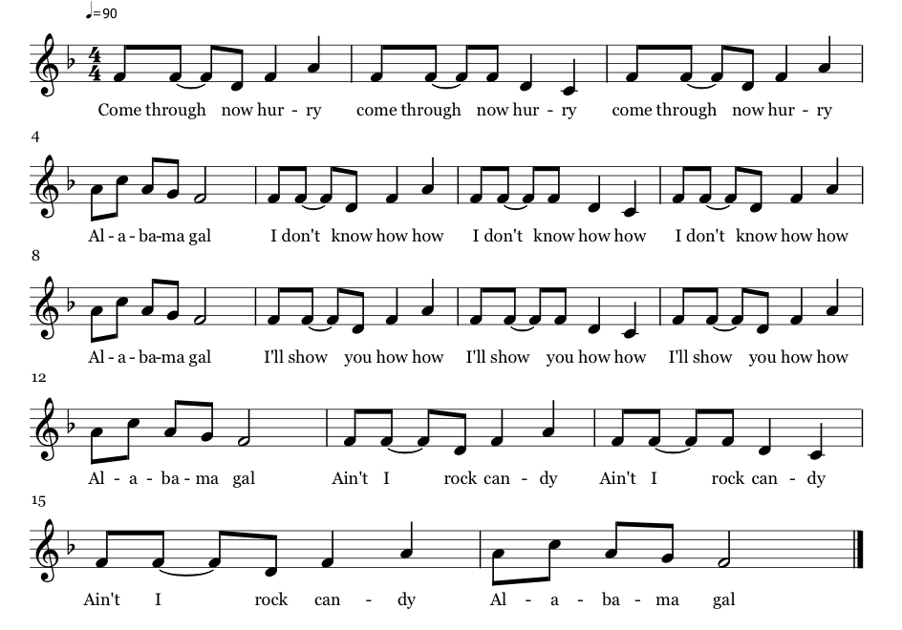

Brief History

Originates from the southern United States during the 1800s, was written during the prohibition of dance amongst young children. It was seen as singing accompanied by movement rather than dancing accompanied by music.

Teaching the Dance

Form two lines, everyone should have a partner. Partners #1 during verse 1 come together, hold hands skip down to the end of the line and back up then fall back in line. Verse 2, each partner will hook with their right elbow for 8 beats, then hook with their left elbow for 8 beats and fall back in line. Verse 3, partners #1 turn away from each other and lead the line to where the partners on the end would be. Verse 4, partners #1 create an arch, the rest of the partners link arms and go under the arch, finishing in a line.

