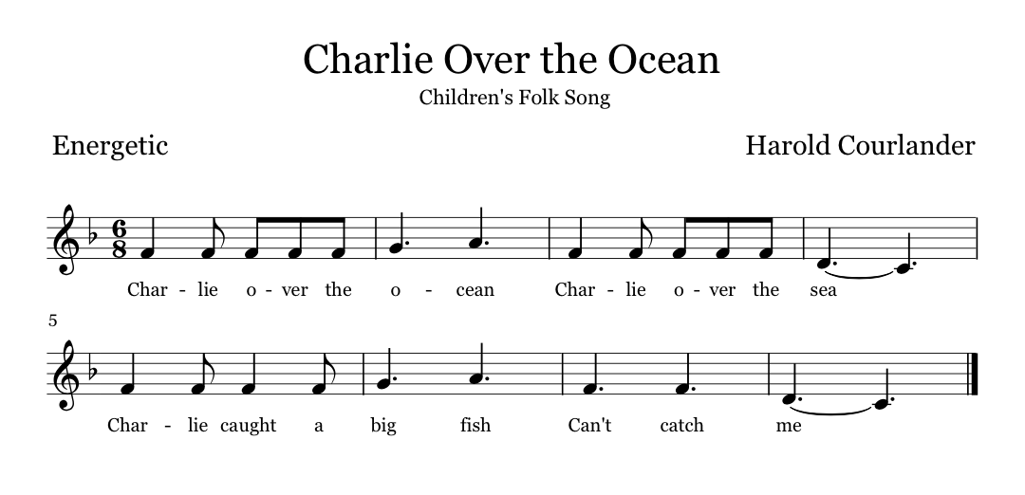

History
This song is believed to be of African American origin. The first location of it was in Harold Courlander’s “Negro Folk Music of Alabama”, which is a collection of music he recorded in rural Alabama in 1950. The song is typically performed by children in call and response style and in a circle formation.

Exercise
A leader will be selected from the class. The group will sit in a circle on the floor and the leader will stand outside of it. The leader is going to sing the first line then the group is going to since it back, continuing this call and response style for the rest of the song. While this occurs, the leader will walk around the outside of the circle until the end of the song at which point they will tap the classmate they are closest to and race them around the circle to the spot where that classmate was sitting. If the leader makes it back first the classmate becomes the leader and the leader takes the classmate’s place, but if the classmate makes it back first the leader remains the leader and the classmate returns to their place.

