Danielle Di Pietrantonio

Lesson Plan: Head and Shoulders, Baby

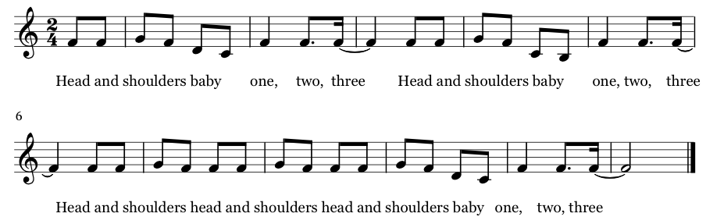

2. Shoulders waist baby one, two, three
Shoulders waist baby one, two, three
Shoulders waist shoulders waist shoulders waist baby one, two, three

Continuing variations:
Waist and knees
Knees and ankles
Ankles toes

Some other variations:
Throw the ball
Milk the cow
Rock the baby
Turn around

End with:
That’s all baby one, two, three
That’s all baby one, two, three
That’s all that’s all that’s all baby one, two, three

Idea to expand on: have students lead and come up with their own instructions!
Before we begin: have everyone close their eyes, understand that at some point I’m going to tap them on the shoulder and then it will be their turn to shout out an action for the next verse.

