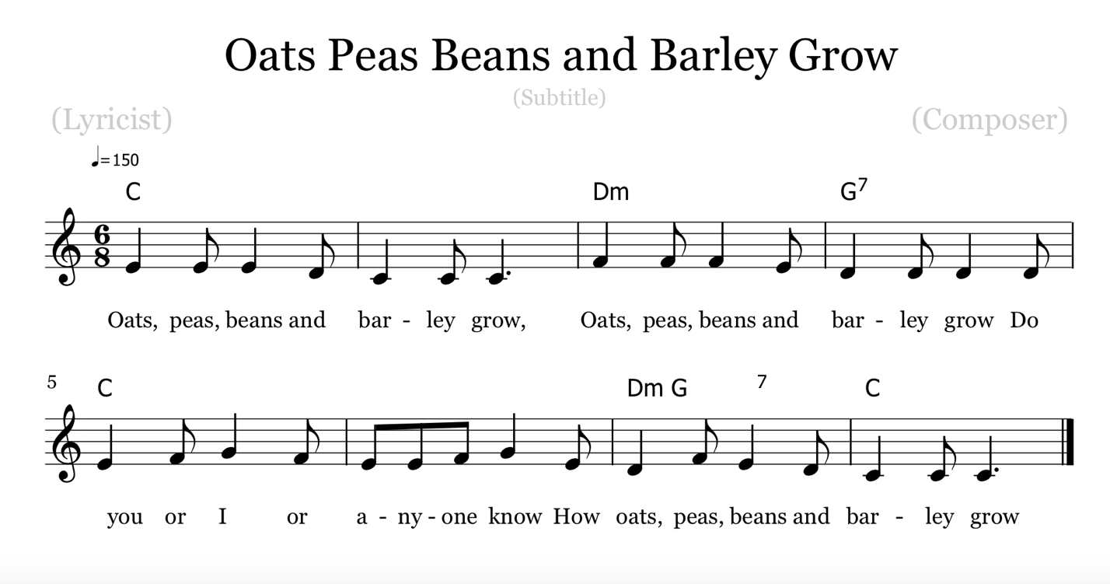

- First the farmer sows her seed,
Then she stands and takes her ease,
She stomps her foot she claps her hands,
And turns around to view the land.

- Waiting for a partner
Waiting for a partner so
Break the ring and choose one in
While all the others clap and sing

- Tra-la-la

Circle Game Instructions:
Formation: Single circle, hands joined together; one player in center as the "farmer."
Action: Circle walks to the left singing verse 1.
On verse 2, the circle stands and joins the farmer in acting out the words.
On the 3rd verse the circle walks to the left while the farmer chooses a partner.
On the last verse the circle stomps their foot and claps their hands to the beat, while the farmer and his partner skip. Partner then becomes the new farmer.

Background Information:
In 1380, this story telling song became a traditional British and American folk song. The tune used to go by the name “Baltimore” but changed as time went on. It is a "play song" and the children perform the actions in the song’s verses. With an obvious connection to the farming community, the children are basically acting out the planting and harvesting of a crop that a farmer does every day for a living. This is a play song according to Alice Bertha Gomme’s 1894 book “The Traditional Games of England, Scotland and Ireland”, in which children perform actions with the song while standing in a ring. This song opens the thought of seeing many generations of children, in so many widely separated lands, who have rejoiced coming together in this song game.

