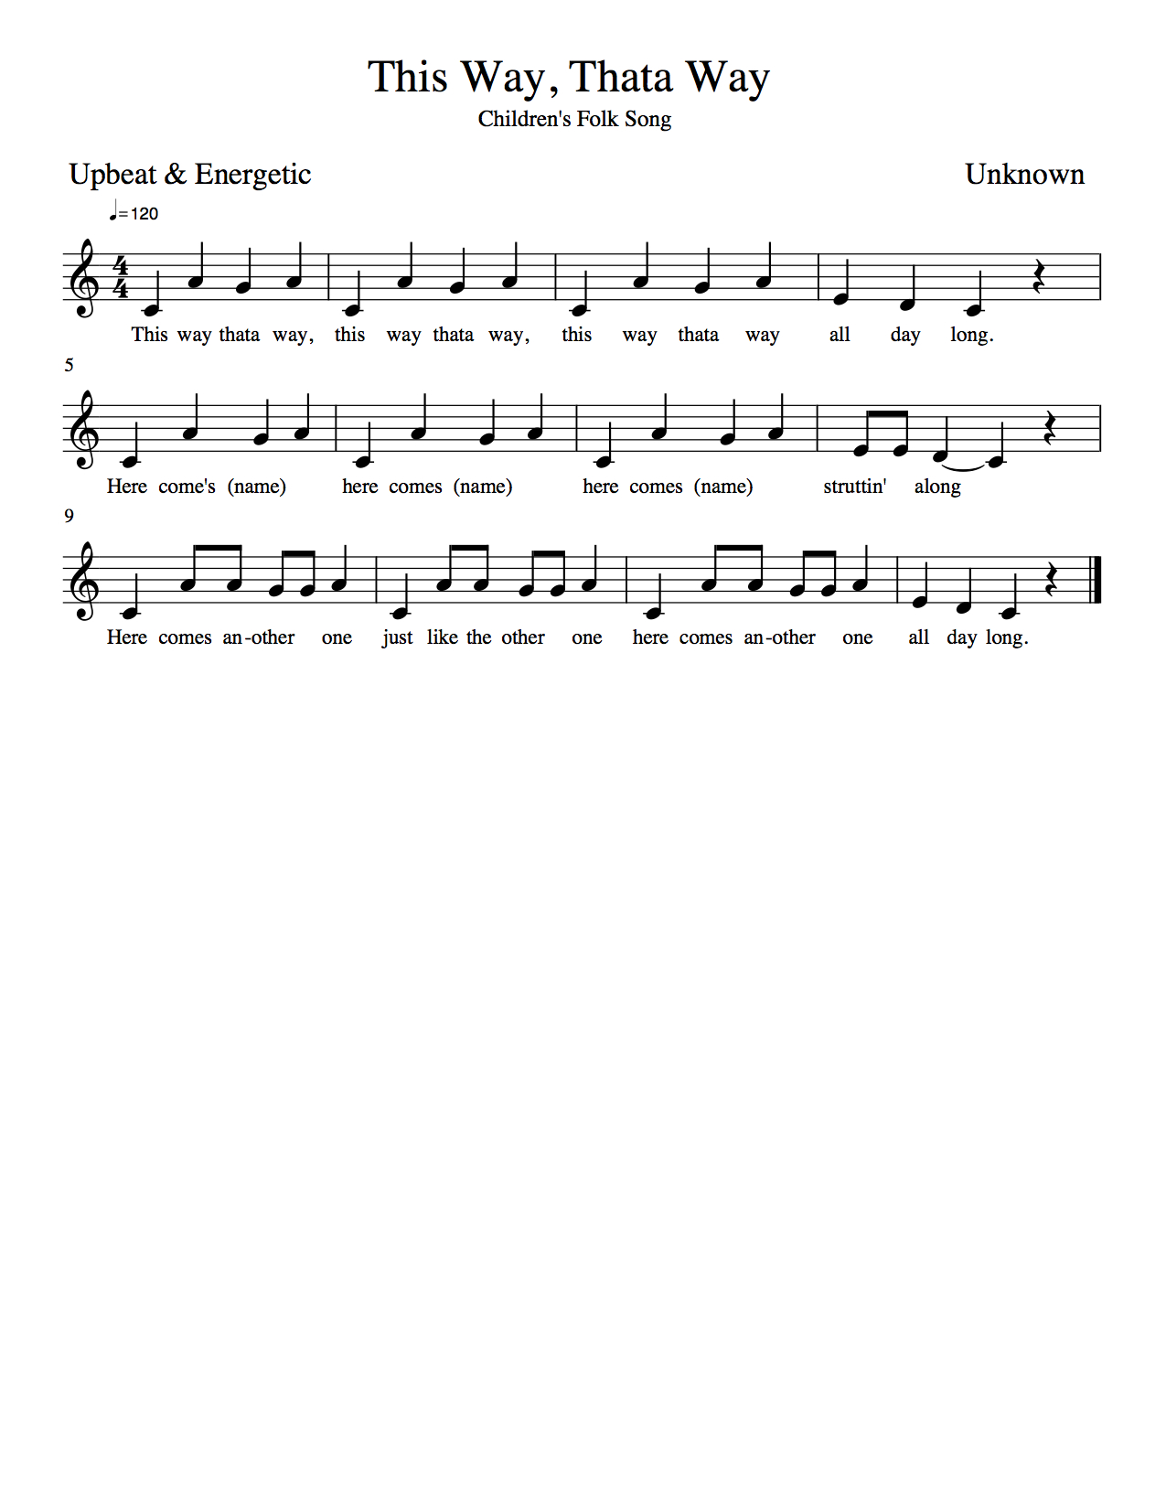

**Origin**: This piece is a traditional children’s folksong that is often performed in primary classrooms. Its exact origins are unknown, but there is a theory that European settlers developed it upon their arrival in Canada.

**Instructions:** Students need to form two lines facing a partner. The song begins with each set of partners holding hands and rocking back and forth from left to right. On the second stanza, the students at the very end of the line break apart and the others follow. The student on the left side will move through the middle of the two lines doing an action of their choice and the class will follow this action as well. On the third stanza, the student on the right comes down the middle and will do an action of their choice and the class will follow it. The two lines meet again and each partner holds hands and repeats the first action from the beginning.

